How do I get started with MSELE?
Before you can log in to MSELE you need a user account or account details (Username and Password) that give you valid access into the LMS. You create a user account on the MSELE interface by completing the Account Creation Form. You need to have a valid/working email address to include in the form. It is to this email address that the MSELE system automatically sends a message with an activation link, to get you started in accessing the LMS. Please note: Your email address is different than your MSELE account and MSELE does not generate email addresses. Please ensure that you have a valid email address first from the free and other available services like yahoo, gmail, among others before you embark on creating a user account in MSELE!
Creating a user account in MSELE
- In a web browser (e.g. Firefox, Internet explorer, Chrome), go to: http://msele.mulagoschoolofnursing.ac.ug
The screen below appears when you open the above MSELE site
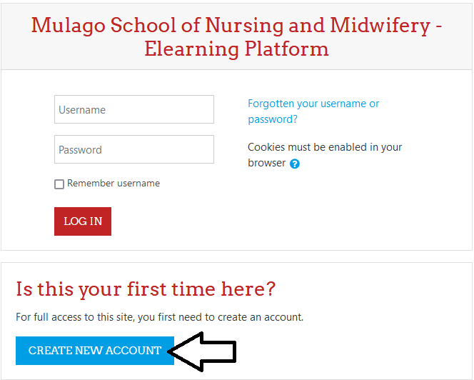

- Click on the login button on the top right indicated with an arrow in the above image. Clicking the login button brings up both the login section (which enables the user to access MSELE with valid username and password), as well as the screen below for new account creation.
- From the page that appears, click on the ‘Create new account’ link

- Fill the form below with the relevant details requested and click ‘create my new account’ at its bottom to submit the form for processing.

The system will warn you if the username you are trying to create is already taken up by another user. In such a case, make the necessary adjustments to your username, submit the form so that you proceed to the next stage of registration.
- In the page that appears next, there will be instructions for you to go to your email address, read the instructions therein, and click on the activation link provided. Click the continue button on this page before proceeding to your email.

Logging in to MSELE
In the login page (described earlier in this document), enter your username and password that you used when creating the account (remember the password settings). Click login when done. Check the top right corner of the page after logging in and if you see your names displayed, then hooray, you have successfully logged in. Always remember to logout whenever you are done working in MSELE.
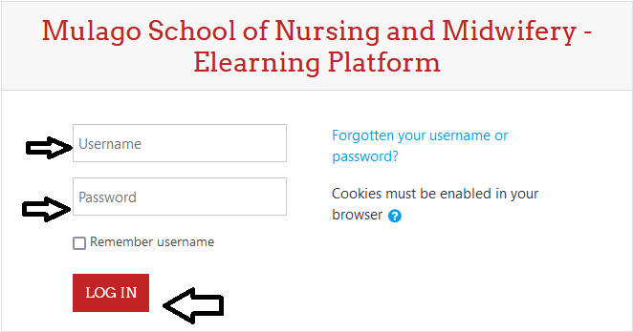

Your profile
Your profile is your identity on MSELE. The first and last name and picture listed in your profile will identify you throughout MSELE. Other MSELE users in your courses can view your profile if they choose to.
Editing your profile
To view your profile, click on your name next to the Logout link at the top of the screen, or anywhere else that your name appears in Moodle. To edit your profile, locate the My Profile settings section within the screen and click the Edit profile link in the Settings block. A page with your details will appear. Use it to change or add whatever is necessary as well as to add your picture if you wish.
● User Picture: You can change your user icon with the “User Picture” field by browsing
for a picture.

Click the User Picture link first to display the image above, then click Add to select your picture and upload it into your profile.
● The Other fields section has fields for various ways other users might want to contact you,
Including mobile phone. Make sure to change your gender here (Female or Male) otherwise it is usually Female by default.
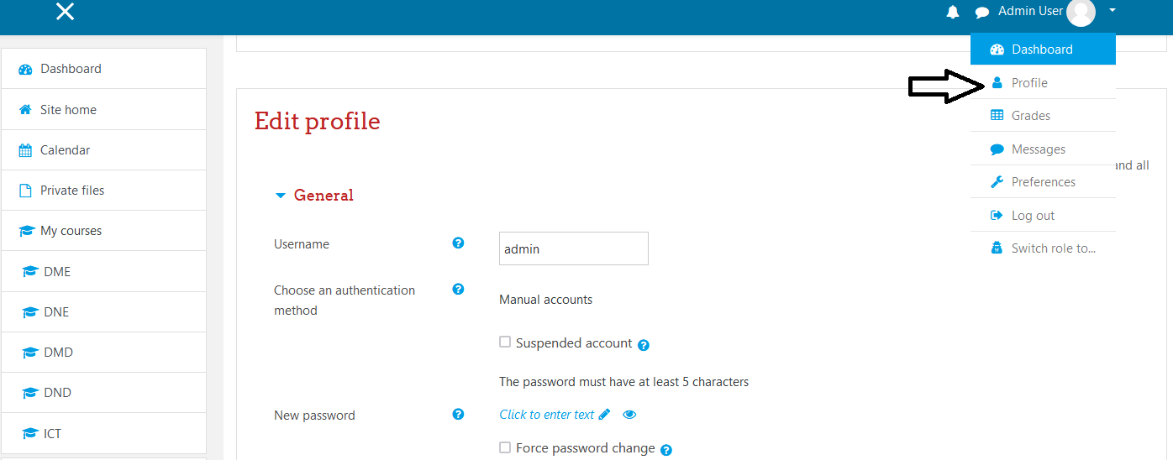
Accessing your MSELE course pages
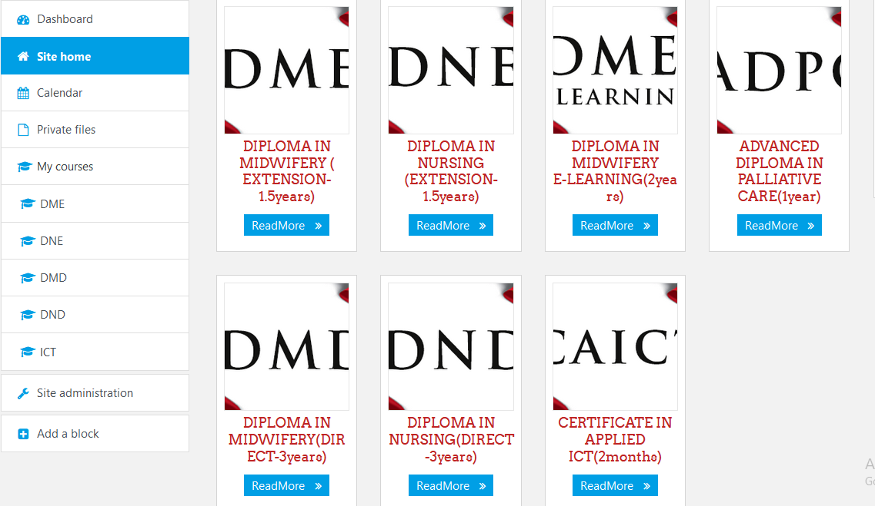
If you are finding problems accessing your favourite course of interest kindly contact the MSELE admin at lwangassali@gmail.com.

